Part 1 overview
A PE format is a data structure that tells the OS loader to load the file into the memory and execute it.
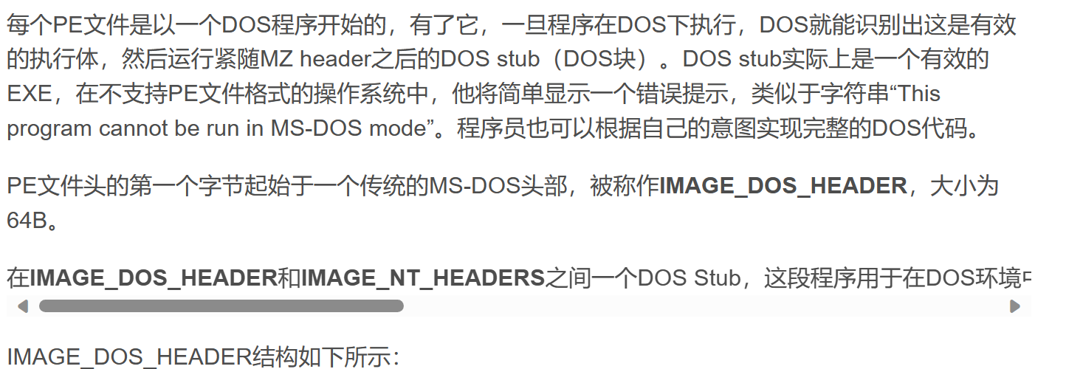
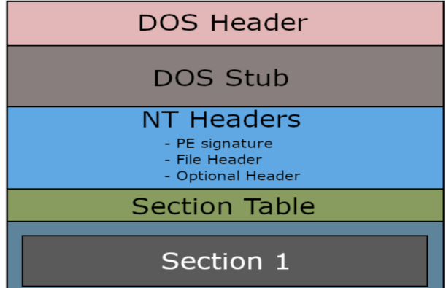
In NT Header,the Optional Header is the most important,because each file has its own Optional Header,right?maybe different exe has different Optional Header,right?
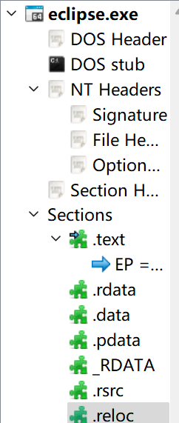
Part 2 the DOS-Header and the DOS-stub and the Rich Header
What is the function of the DOS-Header?I have never used the MS-DOS,my computer is Windows.And the error is ‘This program cannot be run in MS-DOS mode’(这个程序不能运行用MS-DOS 方式运行),does it mean that if i want to run an exe in MS-DOS ,it will throw a error that ‘This program cannot be run in MS-DOS mode’?If i run the exe in Windows,it will run the actual program?Is the MS-DOS widely used?
Thinking: The DOS Header is to stop the file in MS-DOS（目的就是为了让这个程序不在DOS（磁盘操作系统）上运行）

0x4D5A not 0x5A4D? it is a signature tell the computer the file is a MS-DOS executable.Why?If we run it in MS-DOS it will throw a error(we can’t run it in MS_DOS?) but it is called an MS-DOS executable.
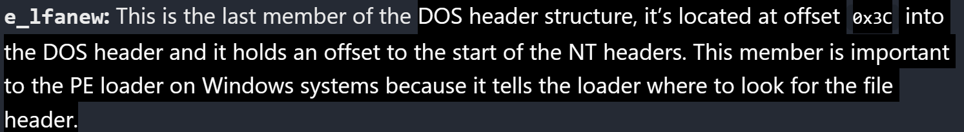
Have some questions
1.1
The offset defined in PE file is relative to the start of the virtual address of the file?
Thinking: yes yes yes.
1.2
What does it say?

